# CentOS

Sudo emacs /etc/sysconfig/network-scripts

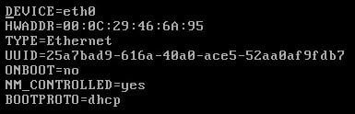

Change it to look like this.

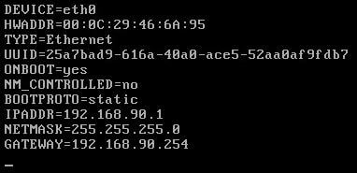

IPADDR

NETMASK

GATEWAY

BOOTPROTO

Change these to match the network

Now edit the resolv file and add proper DNS

**$ sudo nano /etc/resolv.conf**

Nameserver 192.168.1.1

Restart networking

$ service networking restart

# Ubuntu

We just need to edit one file.

**$sudo nano /etc/network/interfaces**

auto ens160

**iface ens160 inet dhcp**

iface <interface> inet static

address 192.168.0.100

netmask 255.255.255.0

gateway 192.168.0.1

**dns-nameservers 8.8.8.8 8.8.4.4**

Make sure <interfaces> matches your correct interface.

Do an ifconfig or ip addr to find out which one needs to be configured.

Also make sure that dns-nameservers points to the right dns.

**Restart NIC**

sudo /etc/init.d/networking restart